**SCIENCEQTECH EMPLOYEE MAPPING PROJECT**

TASK 1

Create a database named employee, then import data_science_team.csv proj_table.csv

and emp_record_table.csv into the employee database from the given resources.

SOL

1. CREATED DATABASE EMPLOYEE USING QUERY

CREATE DATABASE EMPLOYEE;

IMPORTED TABLES FORM RESOURCES.

SCREENSHOTS

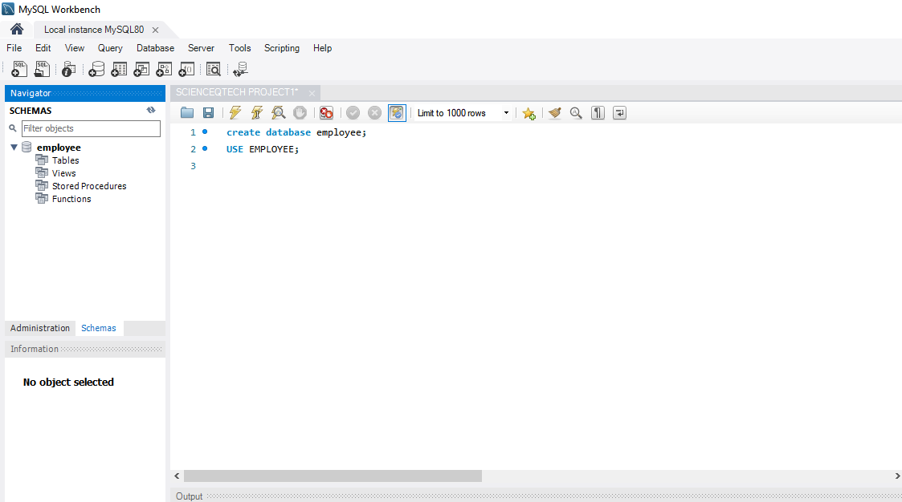

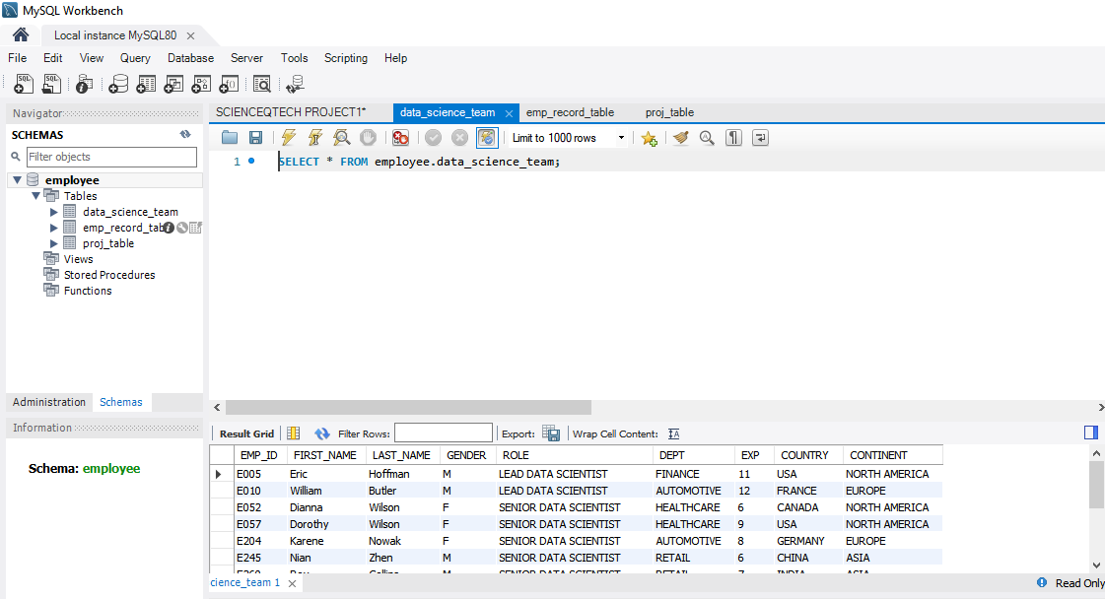

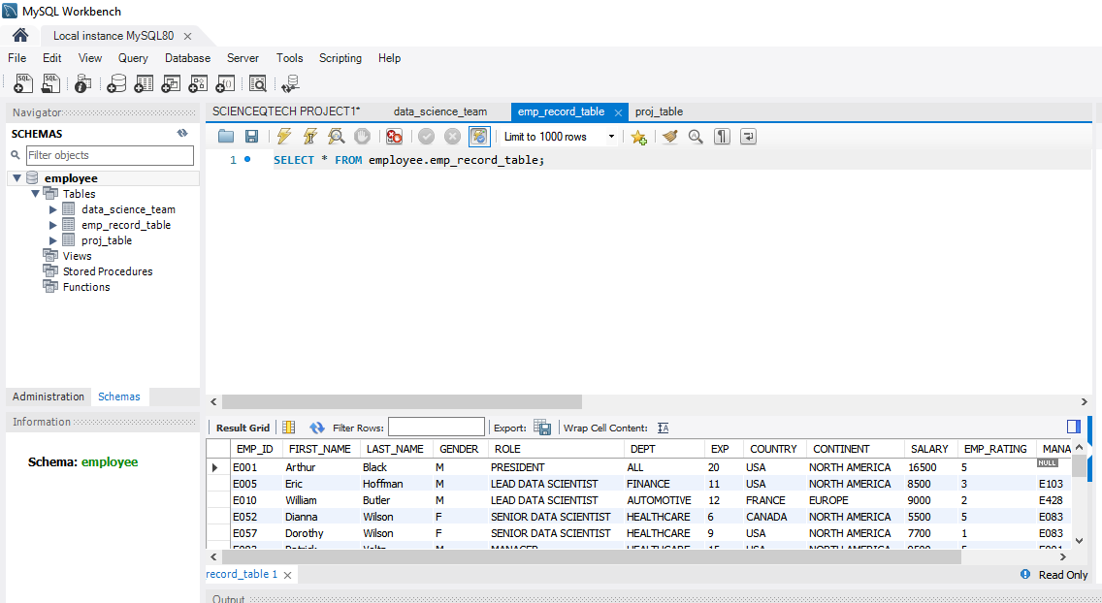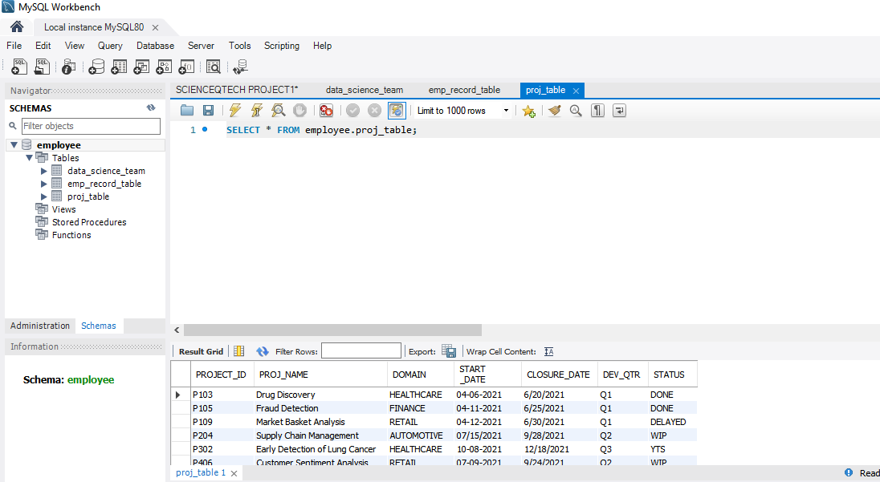

TASK 2

1. Create an ER diagram for the given **employee**database.

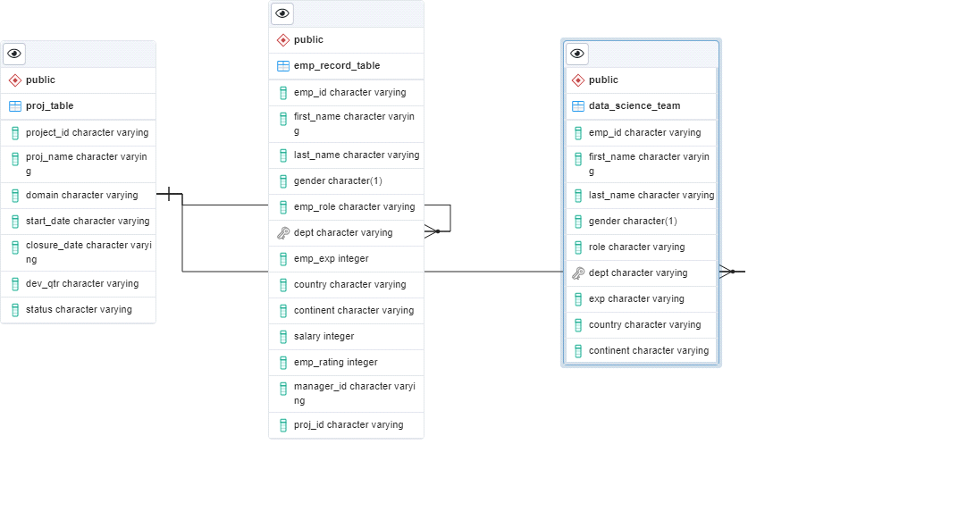

**TASK 3**

1. Write a query to fetch EMP_ID, FIRST_NAME, LAST_NAME, GENDER, and DEPARTMENT from the employee record table, and make a list of employees and details of their department.

**QUERY**

SELECT EMP_ID, FIRST_NAME, LAST_NAME, GENDER, DEPT

FROM employee.emp_record_table

ORDER BY EMP_ID;

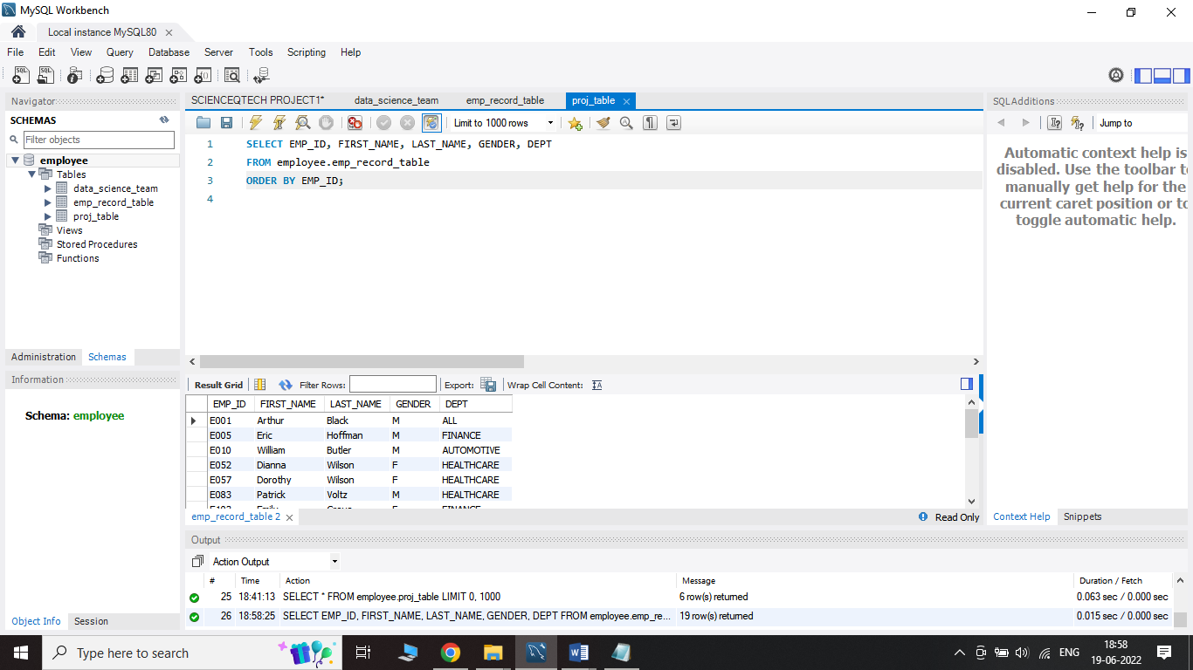

**TASK 4**

1. Write a query to fetch EMP_ID, FIRST_NAME, LAST_NAME, GENDER, DEPARTMENT, and EMP_RATING if the EMP_RATING is:

* less than two
* greater than four
* between two and four

**SOL**

**QUERY**

#EMPLOYEE RATING LESS THAN TWO

SELECT EMP_ID, FIRST_NAME, LAST_NAME, GENDER, DEPT, EMP_RATING

FROM employee.emp_record_table

WHERE EMP_RATING< 2;

#EMPLOYEE RATING GREATER THAN FOUR

SELECT EMP_ID, FIRST_NAME, LAST_NAME, GENDER, DEPT, EMP_RATING

FROM employee.emp_record_table

WHERE EMP_RATING> 4;

#EMPLOYEE RATING BETWEEN TWO AND FOUR

SELECT EMP_ID, FIRST_NAME, LAST_NAME, GENDER, DEPT, EMP_RATING

FROM employee.emp_record_table

WHERE EMP_RATING BETWEEN 2 AND 4;

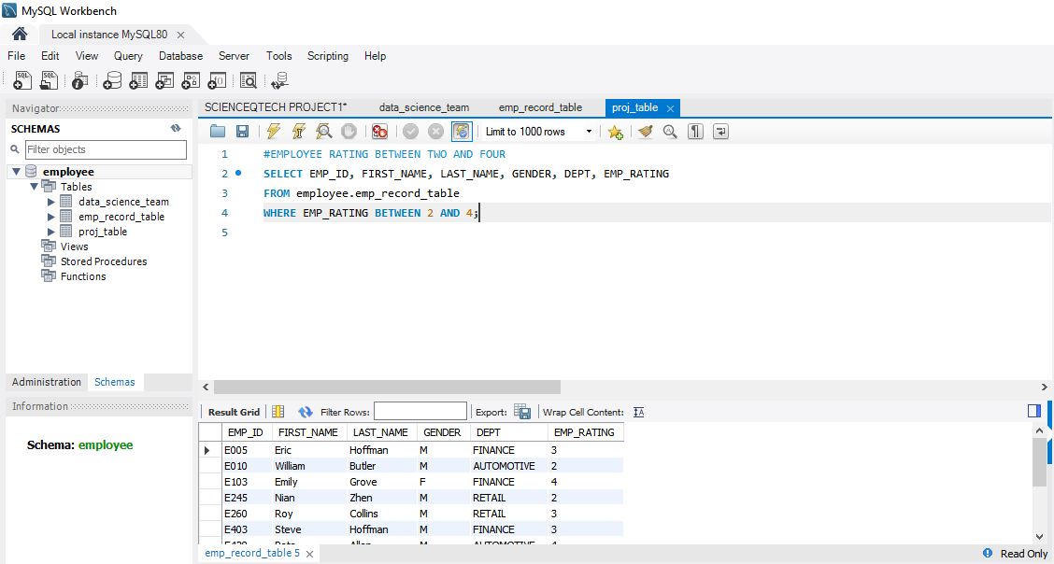

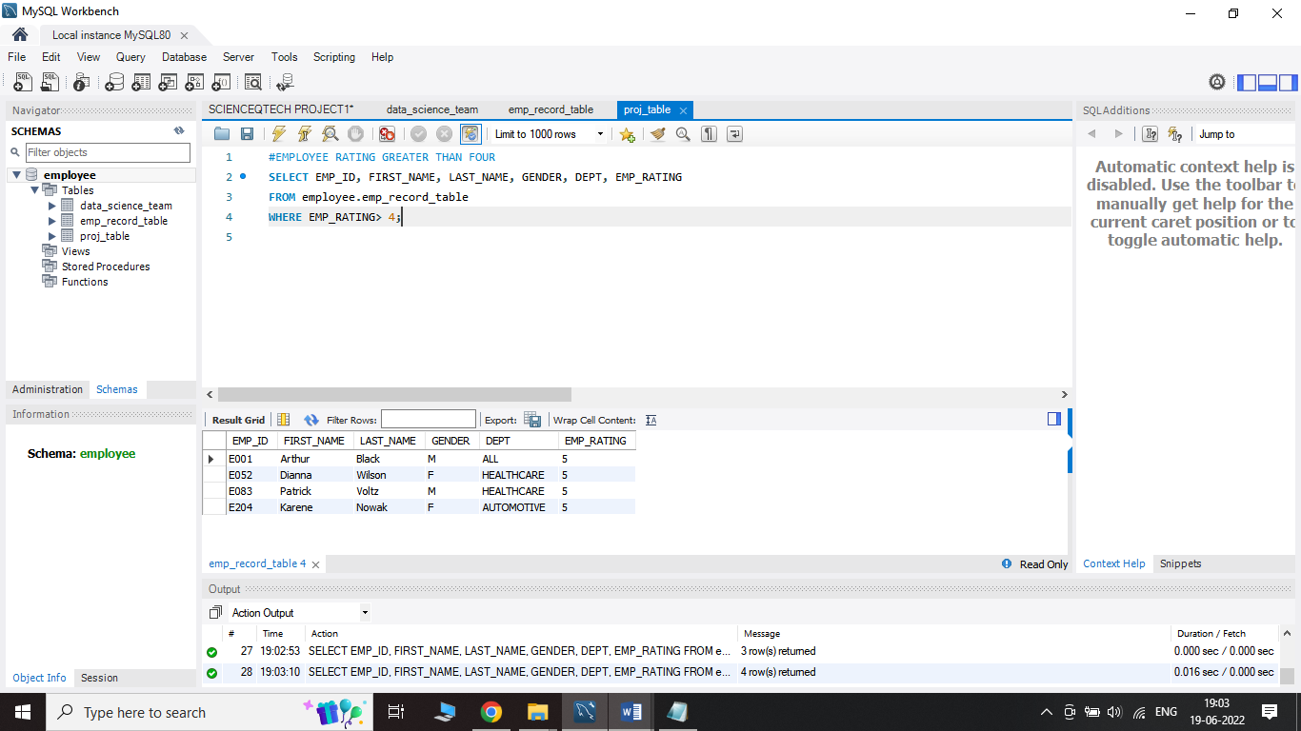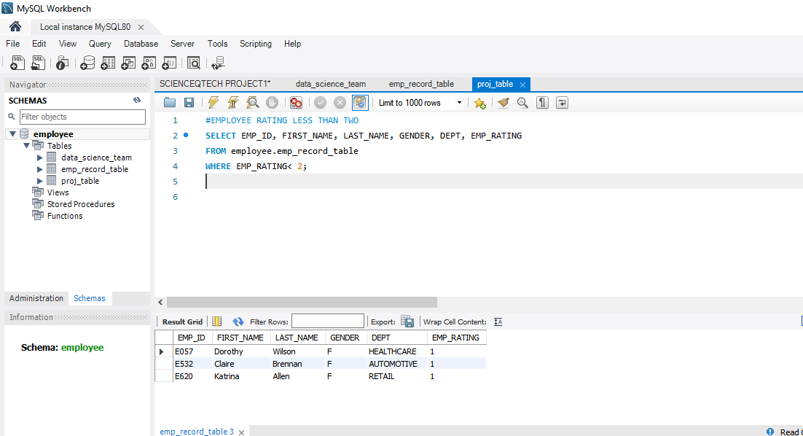

**TASK 5**

1. Write a query to concatenate the FIRST_NAME and the LAST_NAME of employees in the Finance department from the employee table and then give the resultant column alias as NAME.

**QUERY**

SELECT concat(FIRST_NAME, ' ', LAST_NAME) AS 'NAME'

FROM employee.emp_record_table

WHERE DEPT='FINANCE';

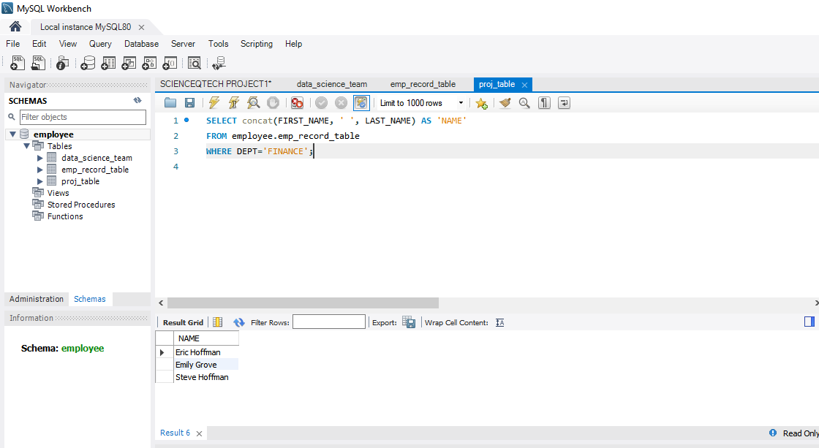

**TASK 6**

1. Write a query to list only those employees who have someone reporting to them. Also, show the number of reporters (including the President).

**QUERY**

select * from emp_record_table

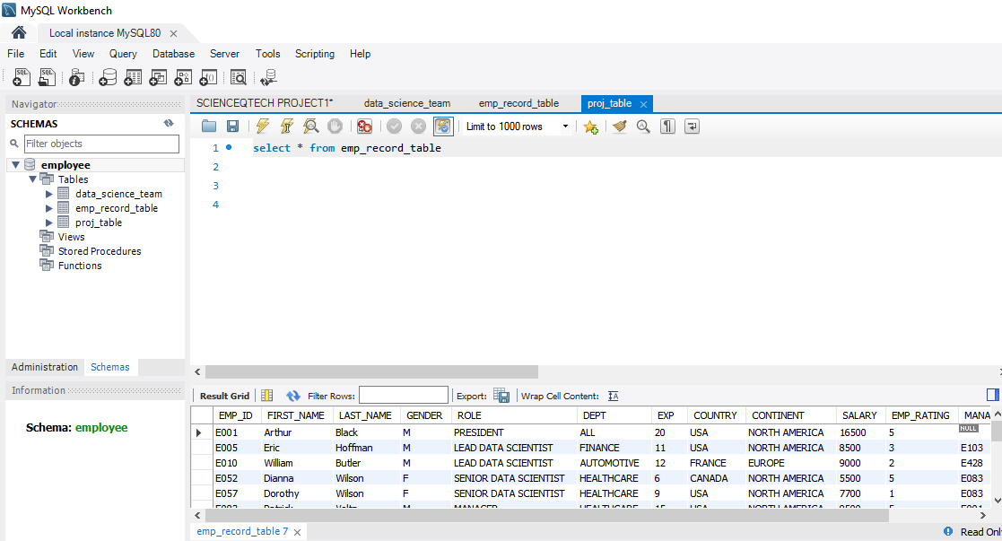

**TASK 7**

1. Write a query to list down all the employees from the healthcare and finance departments using union. Take data from the employee record table.

**QUERY**

SELECT EMP_ID, concat(FIRST_NAME, ' ', LAST_NAME) AS 'NAME'

FROM employee.emp_record_table

WHERE DEPT= 'HEALTHCARE'

UNION

SELECT EMP_ID, concat(FIRST_NAME, ' ', LAST_NAME) AS 'NAME'

FROM employee.emp_record_table

WHERE DEPT= 'FINANCE';

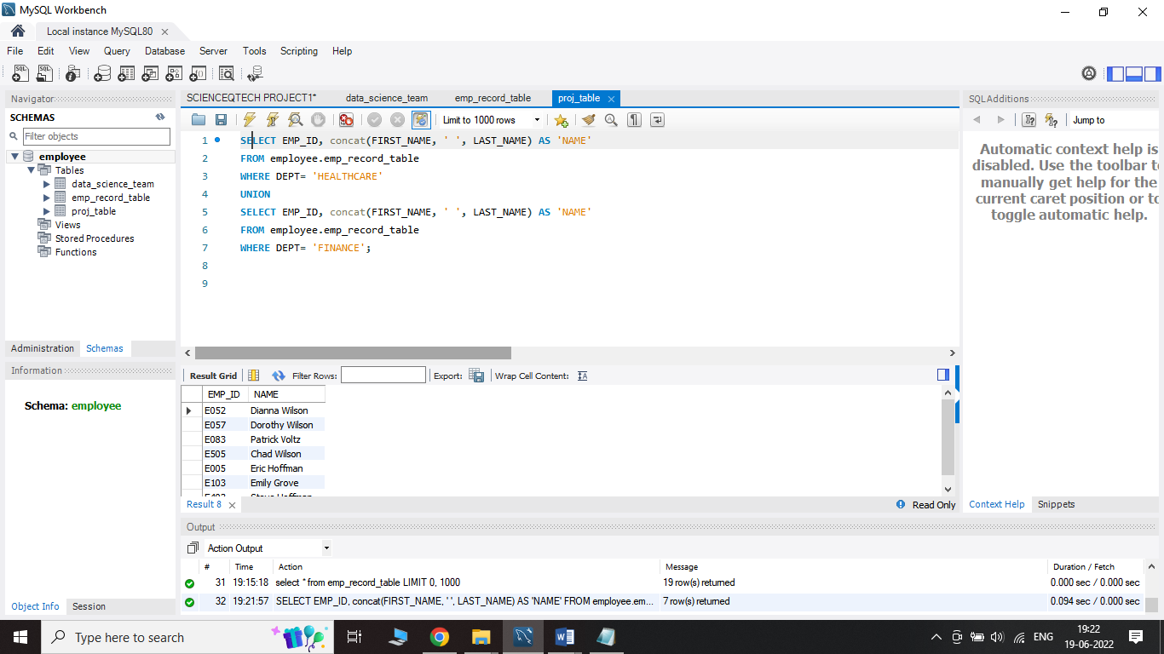

**TASK 8**

1. Write a query to list down employee details such as EMP_ID, FIRST_NAME, LAST_NAME, ROLE, DEPARTMENT, and EMP_RATING grouped by dept. Also include the respective employee rating along with the max emp rating for the department.

**QUERY**

SELECT EMP_ID, FIRST_NAME, LAST_NAME, ROLE , DEPT ,EMP_RATING, max(EMP_RATING) OVER (PARTITION BY DEPT) AS MAX_EMP_RATING

FROM employee.emp_record_table

ORDER BY DEPT;

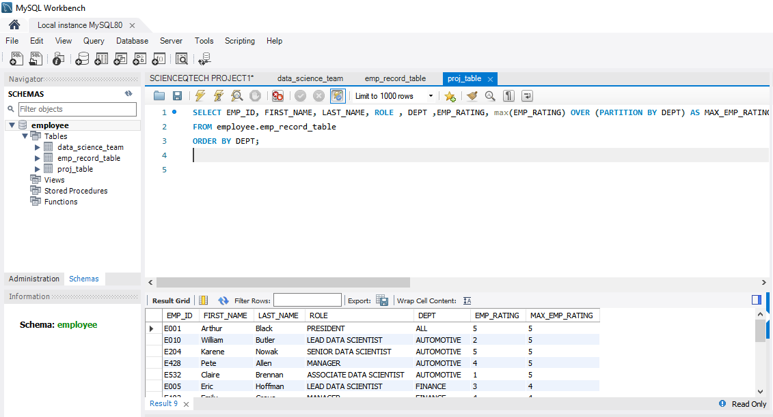

**TASK 9**

1. Write a query to calculate the minimum and the maximum salary of the employees in each role. Take data from the employee record table.

**QUERY**

SELECT EMP_ID, SALARY, ROLE, MAX(SALARY) OVER (PARTITION BY ROLE) AS MAX_SALARY, MIN(SALARY) OVER (PARTITION BY ROLE) AS MIN_SALARY

FROM employee.emp_record_table;

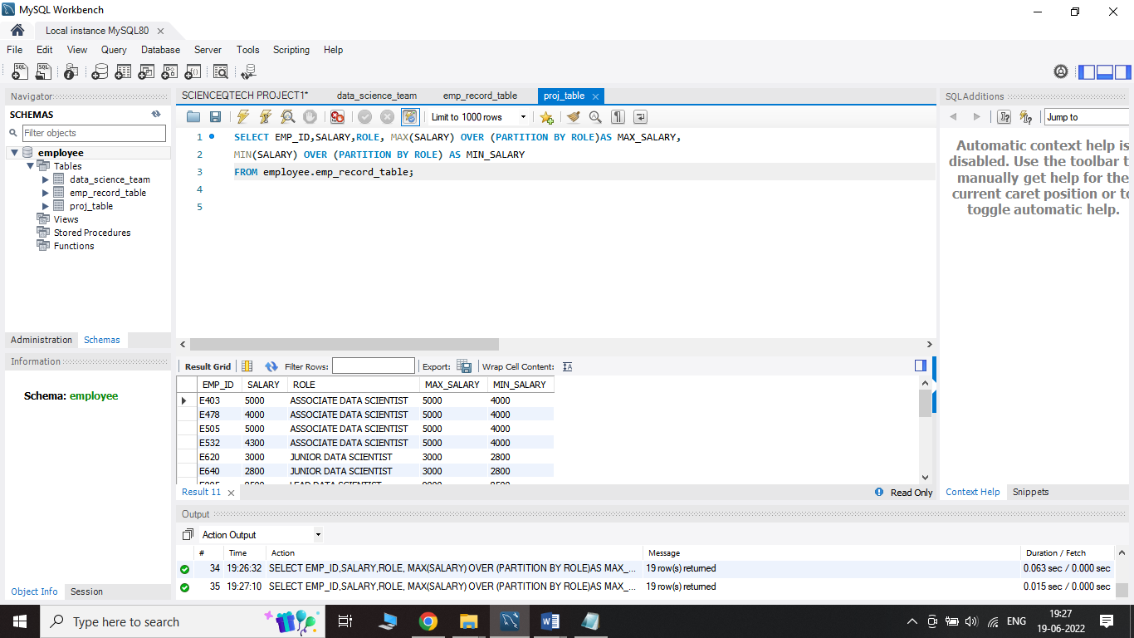

**TASK 10**

1. Write a query to assign ranks to each employee based on their experience. Take data from the employee record table.

**QUERY**

SELECT EMP_ID , concat(FIRST_NAME," ",LAST_NAME) AS NAME, EXP, RANK() OVER(ORDER BY EXP DESC) EXP_RANK

FROM employee.emp_record_table;

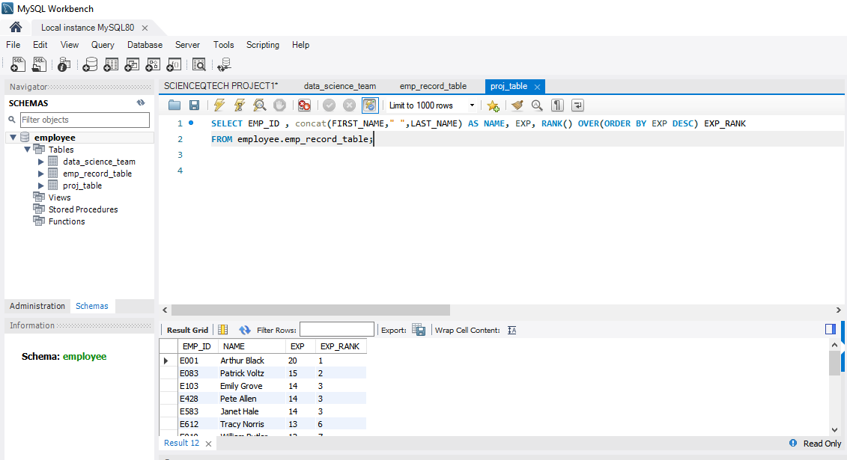

**TASK 11**

1. Write a query to create a view that displays employees in various countries whose salary is more than six thousand. Take data from the employee record table.

**QUERY**

CREATE VIEW EMP_HIGH_SALARY AS

SELECT EMP_ID, FIRST_NAME, LAST_NAME, COUNTRY

FROM employee.emp_record_table

WHERE SALARY> 6000;

SELECT* FROM EMP_HIGH_SALARY;

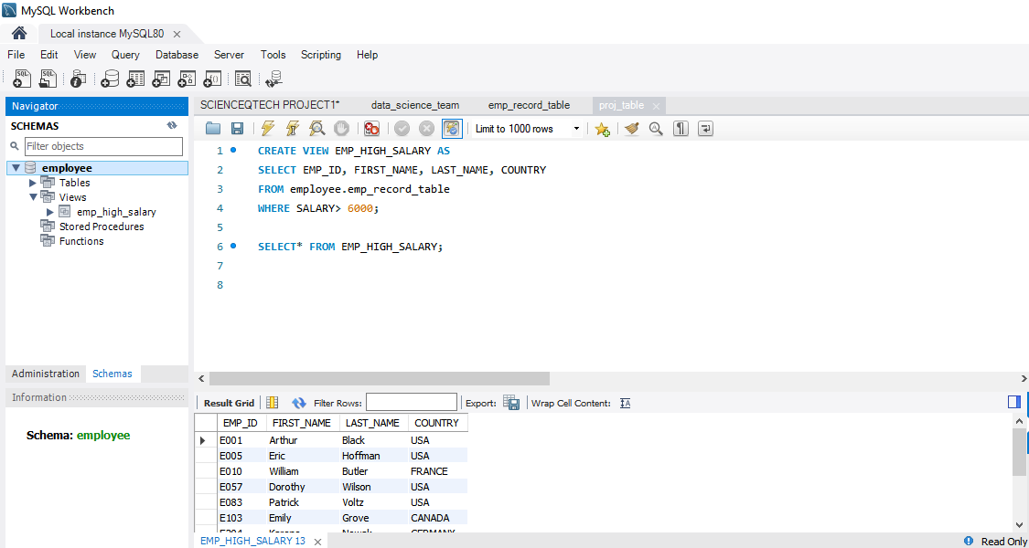

**TASK 12**

1. Write a nested query to find employees with experience of more than ten years. Take data from the employee record table.

**QUERY**

SELECT first_name, last_name, exp

from employee.emp_record_table

where emp_id in(

select emp_id from employee.emp_record_table

where exp>10);

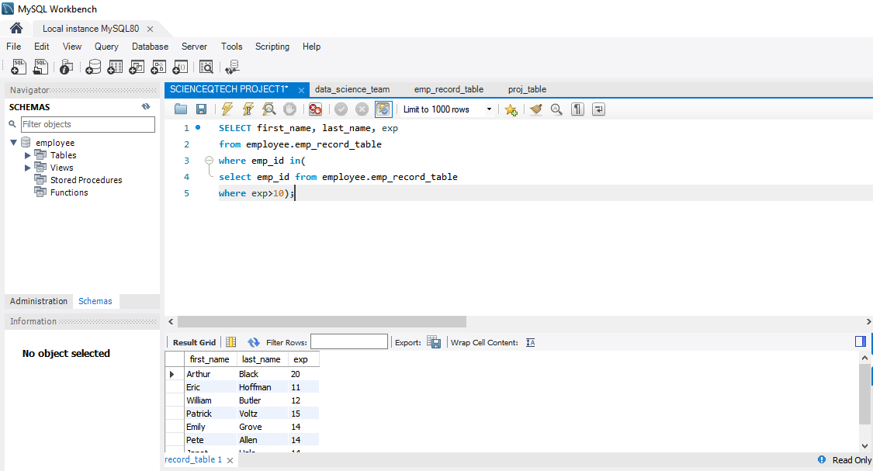

**TASK 13**

1. Write a query to create a stored procedure to retrieve the details of the employees whose experience is more than three years. Take data from the employee record table.

**QUERY**

DELIMITER **&&**

**CREATE procedure EXP_MORE_THAN_3()**

**BEGIN**

**SELECT*FROM employee.emp_record_table WHERE EXP>3;**

**END &&**

**CALL EXP_MORE_THAN_3();**

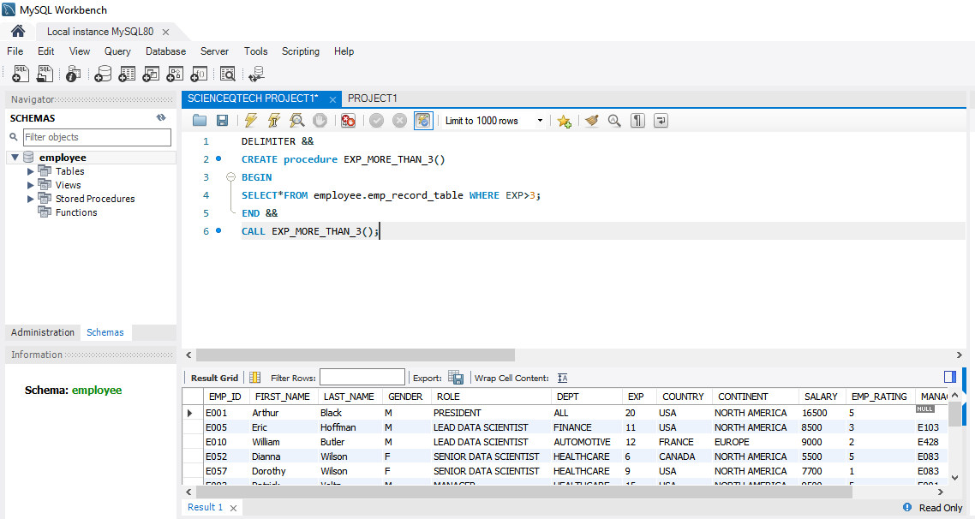

**TASK 14**

1. Write a query using stored functions in the project table to check whether the job profile assigned to each employee in the data science team matches the organization’s set standard.

The standard being:

For an employee with experience less than or equal to 2 years assign 'JUNIOR DATA SCIENTIST',

For an employee with the experience of 2 to 5 years assign 'ASSOCIATE DATA SCIENTIST',

For an employee with the experience of 5 to 10 years assign 'SENIOR DATA SCIENTIST',

For an employee with the experience of 10 to 12 years assign 'LEAD DATA SCIENTIST',

For an employee with the experience of 12 to 16 years assign 'MANAGER'.

**QUERY**

DELIMITER \\

CREATE FUNCTION DESIGNATION(EXP INT)

RETURNS VARCHAR(100)

deterministic

BEGIN

declare DESIGNATION VARCHAR(100);

IF EXP <= 2 THEN SET DESIGNATION = 'JUINOR DATA SCIENTIST';

ELSEIF EXP <= 5 THEN SET DESIGNATION ='ASSOCIATE DATA SCIENTIST';

ELSEIF EXP <= 10 THEN SET DESIGNATION=' SENIOR DTA SCIENTIST';

ELSEIF EXP <=12 THEN SET DESIGNATION ='LEAD DATA SCIENTIST';

ELSEIF EXP>12 THEN SET DESIGNATION ='MANAGER';

ELSE SET DESIGNATION= 'INVALID';

END IF;

RETURN (DESIGNATION);

END \\

SELECT FIRST_NAME, LAST_NAME , DEPT, DESIGNATION(EXP) FROM EMPLOYEE.DATA_SCIENCE_TEAM;

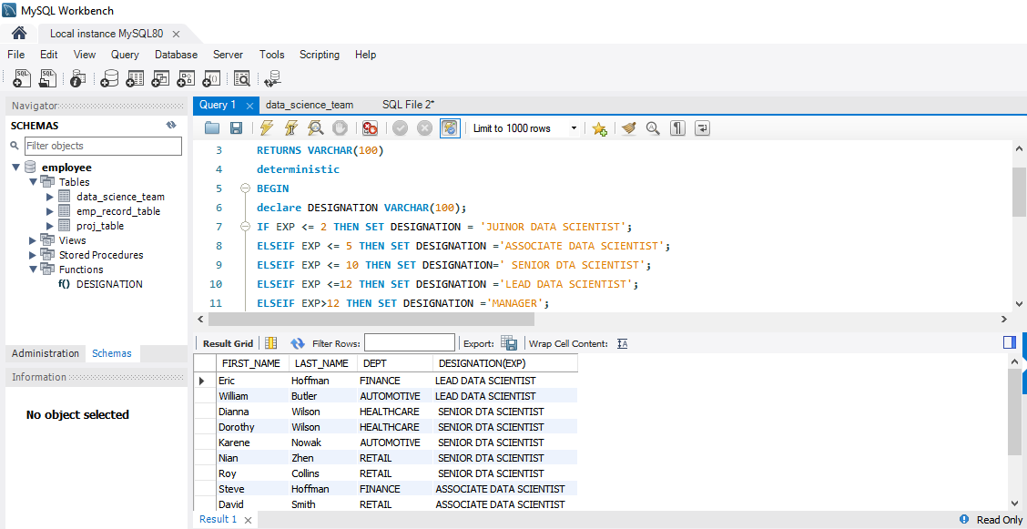

**TASK 15**

1. Create an index to improve the cost and performance of the query to find the employee whose FIRST_NAME is ‘Eric’ in the employee table after checking the execution plan.

**QUERY**

create index firstname_ on emp_record_table(first_name);

explain select * from emp_record_table where FIRST_NAME='eric';

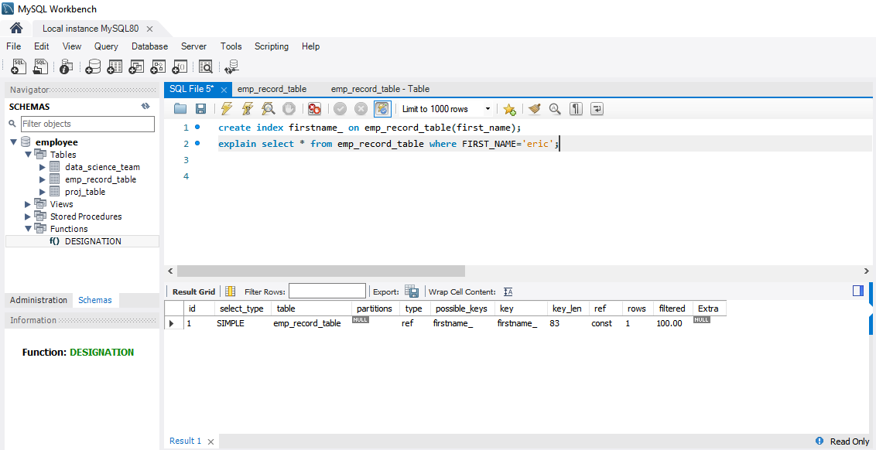

**TASK 16**

1. Write a query to calculate the bonus for all the employees, based on their ratings and salaries (Use the formula: 5% of salary * employee rating).

**QUERY**

SELECT emp_id,salary,emp_rating,((salary*5/100)*emp_rating) as bonus FROM emp_record_table;

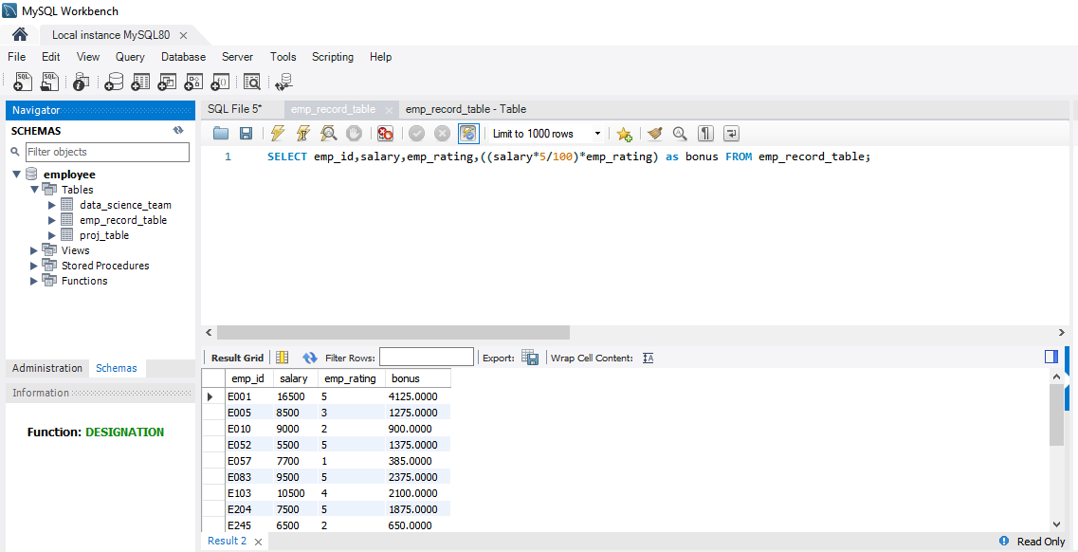

**TASK 17**

1. Write a query to calculate the average salary distribution based on the continent and country. Take data from the employee record table.

**QUERY**

SELECT continent, avg(Salary) FROM emp_record_table group by continent;

SELECT country, avg(Salary) FROM emp_record_table group by country;

select continent,

(select avg(b.Salary) from emp_record_table b where a.continent = b.continent) as continentAvg,

country,

(select avg(c.Salary) from emp_record_table c where a.country = c.country) as countryAvg

FROM emp_record_table a

group by continent,country;

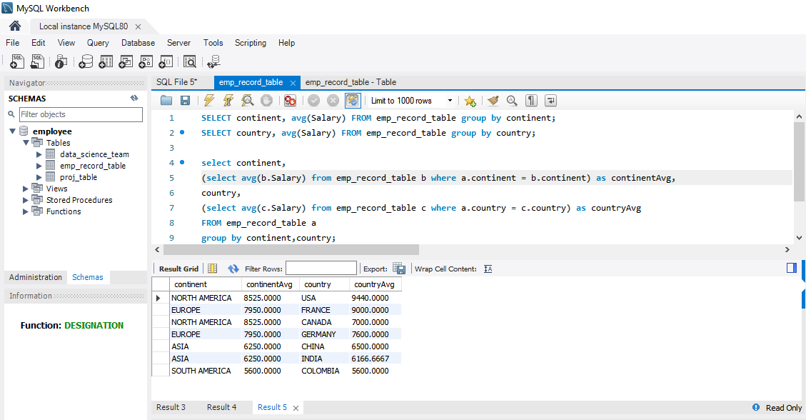

END OF PROJECT